Smt. R.P. Chauhan Arts & Smt. J.K. Shah & Shri K.D. Shah Commence College,
&
K.R.P. Darjee Indo-American Institute of Computer Science.
Vyara394650 Dist. Tapi. (Guj.)
SEXUAL HARASSMENT COMPLAINTS COMMITTEE
Year : 2022-23

Sr.No. | Name | Address & Contact Number
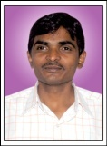 | Prof. Somabhai R. Chaudhari | Associate Professor Arts & Commerce College, Vyara. M.No.9427125151
 | Prof. Smt. Bhamini D. Shah | Associate Professor Arts & Commerce College, Vyara. M.No.9726004906
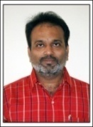 | Dr. Dharmesh C. Pandya | Associate Professor  Arts & Commerce College, Vyara. M.No. 9426848081
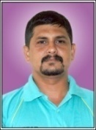 | Prof. Sanjay G. Kosada | Associate Professor  Arts & Commerce College, Vyara. M.No. 9879071219
 | Prof. Smt. Mital M. Desai | Associate Professor Arts & Commerce College, Vyara. M.No.9428630894
 | Dr. Smt. Shobhna P. Jain | Associate Professor Arts & Commerce College, Vyara. M.No.9427869369
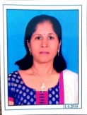 | Prof. Miss. Ranjanben Rana | Associate Professor Arts & Commerce College, Vyara.  M.No.8849322618
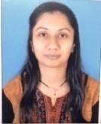 | Prof. Smt. Bhaviniben K. Shah | Assist. Professor  Arts & Commerce College,Vyara.  M.No. 7567818440
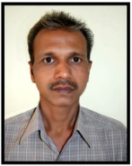 | Shri Manubhai Chaudhari | Sr. Clerk  Arts & Commerce College,Vyara.  M.No. 9879413710


Principal

