Smt. R.P. Chauhan Arts & Smt. J.K. Shah & Shri K.D. Shah Commece College, Vyara394650 Dist.Tapi.(Guj.)
IQAC(Internal Quality Assurance Cell) Committee
Year : 2022-23

 | 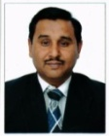  Prin. Dr. H.Y. Kharvaiya  Chair Person | Principal  Arts & Commerce College, Vyara. Dist. Tapi  M.No. 9727156028
 |   Prof. Dr. A.B. Naik  Co-ordinator | Head -Dept. of Economics  Arts & Commerce College, Vyara. Dist. Tapi M.No. 9427812943
 |   Prof. V.H. Gamit | Vice- Principal - Dept. of Gujarati –PG In-charge  Arts & Commerce College, Vyara. Dist. Tapi M.No. 9913210002
 | 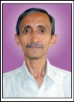  Prof. C.J. Bhatt | Head-Dept. of Commerce  Arts & Commerce College, Vyara. Dist. Tapi M.No. 7567945053
 | 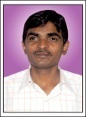  Prof. S.R. Chaudhari | Head-Dept. of Gujarati  Arts & Commerce College, Vyara. Dist. Tapi M.No. 9427125151
 |   Prof. Mrs. B.D. Shah | Dept. of Commerce, NCC  Arts & Commerce College, Vyara. Dist. Tapi M.No.9726004906
 |   Prof. Smt. B. K. Bendre | Head- Dept. of Sociology  Arts & Commerce College, Vyara. Dist. Tapi M.No.9099111600
 |   Prof. Smt. G. N. Patel | Head- Dept. of English  Arts & Commerce College, Vyara. Dist. Tapi M.No.7567472124
 |   Prof. S.G. Kosada | Dept. of Physical Education  Arts & Commerce College, Vyara. Dist. Tapi M.No. 9879071219

Smt. R.P. Chauhan Arts & Smt. J.K. Shah & Shri K.D. Shah Commece College, Vyara394650 Dist.Tapi.(Guj.)
IQAC(Internal Quality Assurance Cell) Committee
Year : 2022-23

 |   Prof. Smt. M.M. Desai | Dept. of English  Arts & Commerce College, Vyara. Dist. Tapi  M.No.9428630894
 |   Prof. C.D. Shah | Head -Dept. of BCA  Assist. Professor  Arts & Commerce College,Vyara. Dist. Tapi  M.No. 9825902140 9
 |   Pro.Dr. D.B. Soni | Dept. of BCA  Arts & Commerce College,Vyara. Dist. Tapi  M.No. 033769353
 | 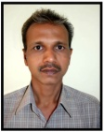  Shri M.D. Chaudhari | College Administrative Member  Arts & Commerce College, Vyara. Dist. Tapi M.No.9879413710
 | 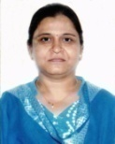  Miss S.S. Pawar | System Analyst  Arts & Commerce College, Vyara. Dist. Tapi M.No.9825969853
 | 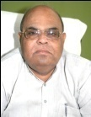  Shri Hasubhai D. Bhakta | President of Shree R.F. Daboo Education Society, Vyara Chairman, Dadaria Sugar Factory,  Honor, Tapti Carbonic, Vyara. Dist. Tapi  M.No. 9925944555
 | 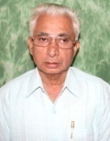  Shri Maheshbhai M. Shah | Local Society Management Representative  Secretary, Shree R.F. Daboo Education Society, Vyara. Dist. Tapi  M.No.9898097300
 | 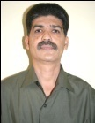  Shri Nevilbhai Jokhi | Stakeholder & Builders  Chairman, Shree R.F. Daboo Education Society, Vyara. Dist. Tapi  M.No.9824114141


Principal

